OPERATING SYSTEM AND SYSTEM PROGRAMMING [OSSP]
{SKILL}
WEEK – 1
TASK 1: 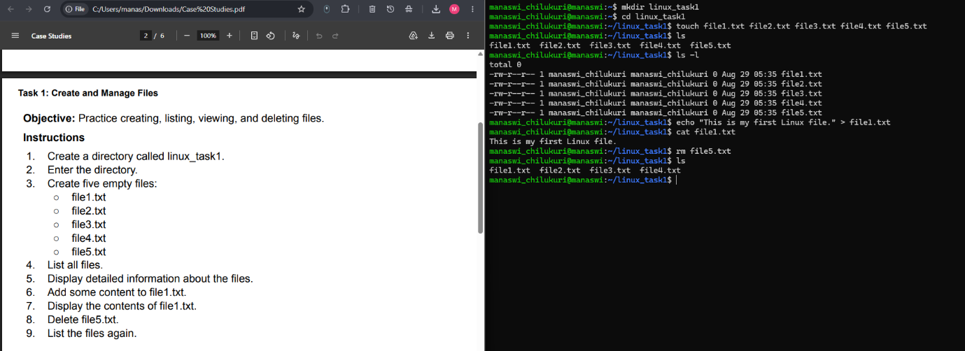TASK 2: 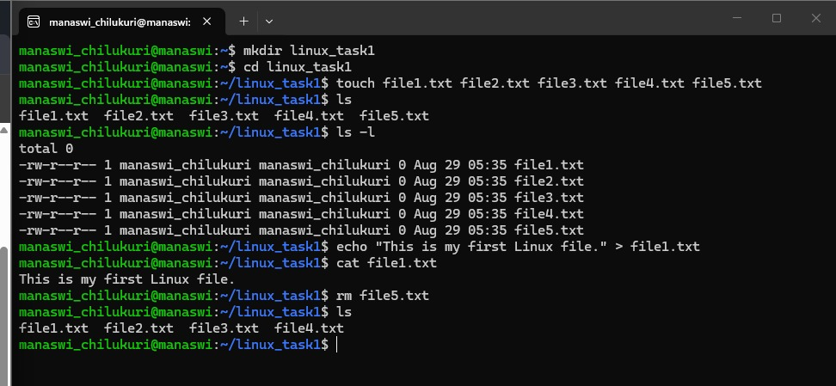
TASK 3 :

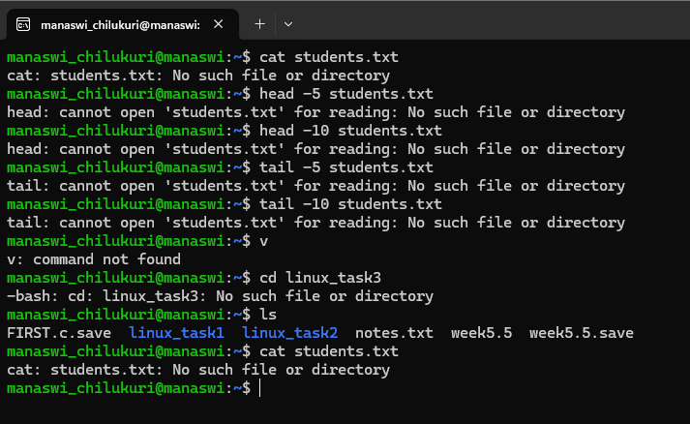
TASK 4:
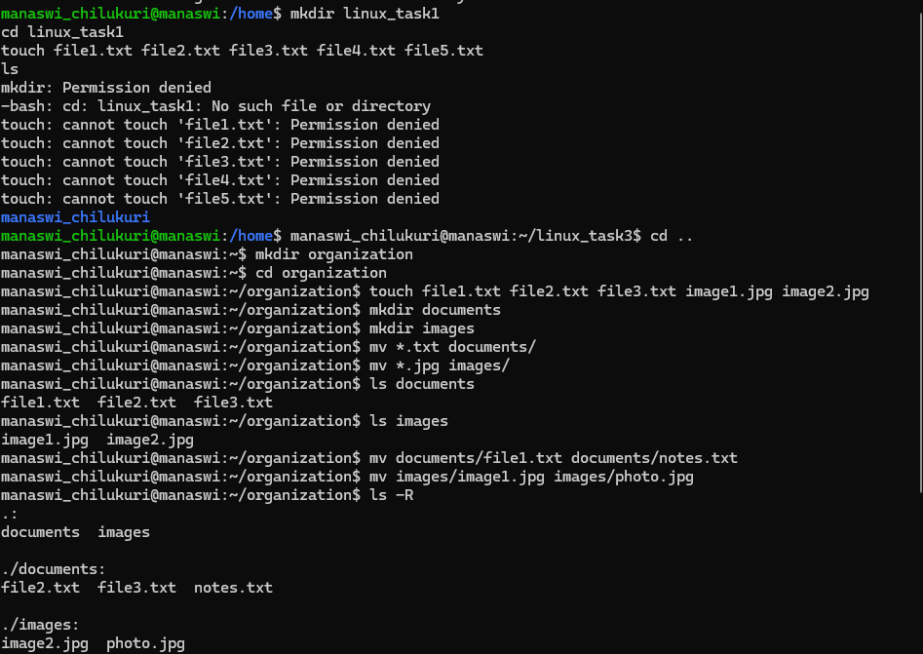
Week 5 : 